This is second quesion output :-

First i comple the server.java and client.java

After that start rmiregistry

Then run the server

And after that run client and put the intervel 100

Get result with 100 is : 3.0924

and put the intervel 3

get rusult with 3 is : 3.11111111

and put the intervel 5

get rusult with 5 is:2.08

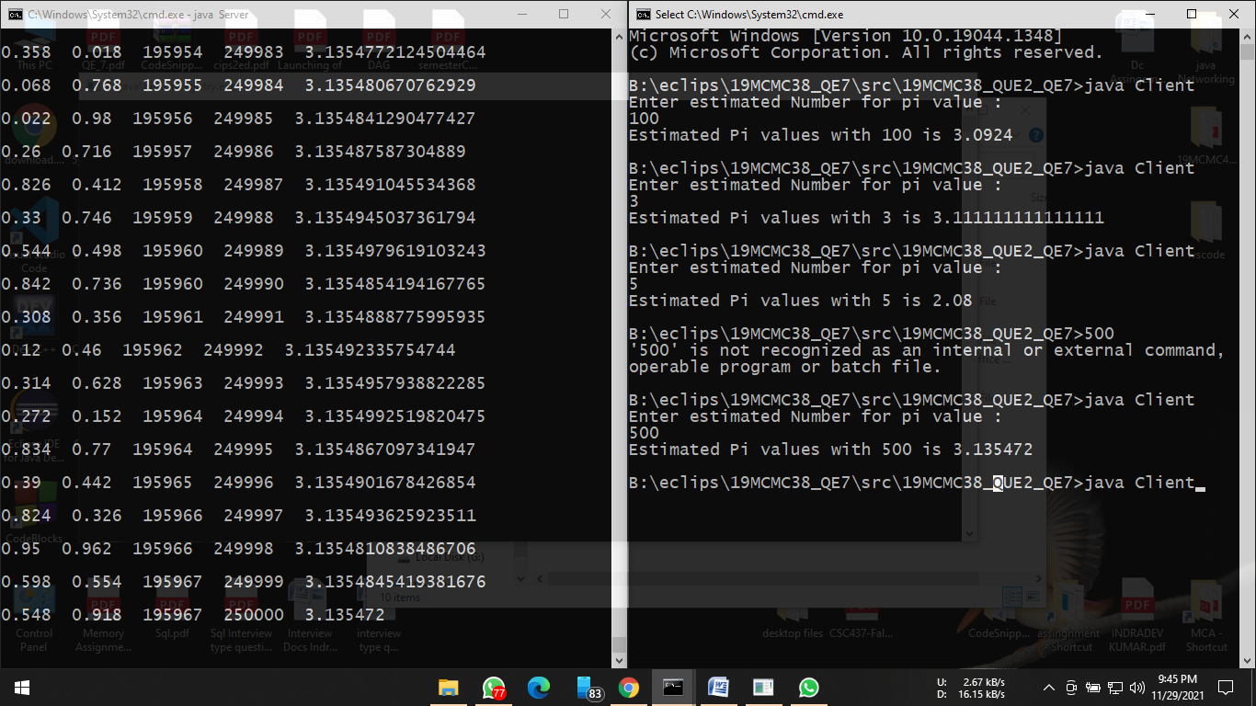

and put the intervel 1000

get rusult with 1000 : 3.1412

